NORTHWIND TRADERS
Power BI Dashboard Documentation
Simple Project Documentation | MySQL → Power BI
Database
The Northwind dataset was imported into MySQL using the database name `traders`. The required tables were then connected to Power BI Desktop for analysis and dashboard creation.

1. Problem Statement
The objective of this Power BI report is to create a visually appealing and user-friendly dashboard for Northwind Traders. The report analyzes customer behavior, order trends, sales performance, employees, products, pricing and suppliers. Interactive filters and visualizations help users explore the data and support data-driven decision making.

2. Project Objectives
- Import the Northwind dataset into MySQL.
- Use the MySQL database `traders` as the Power BI data source.
- Analyze customer, order, product, employee and supplier information.
- Create a three-page Power BI dashboard.
- Answer all 15 required analytical questions.
- Use interactive slicers and navigation for easy data exploration.

3. Dataset and Tables
The Northwind database contains sales information for the fictitious company Northwind Traders, which imports and exports specialty foods from around the world.
Table | What it contains
traders customers | Customer details, contact title and geographical information.
traders orders | Order dates, customers, employees, shipping dates and shipping information.
traders order_details | Products purchased, quantity, unit price and discount for each order.
traders products | Product names, suppliers, categories, unit prices and inventory information.
traders categories | The eight product categories and their descriptions.
traders suppliers | Supplier details and supplier geographical information.
traders employees | Employee details, job title, hire date and reporting information.
Unused table
The Shippers table was imported/available in the source dataset but was not used in the final analysis. No relationship with other tables was created for Shippers, so it is not used in the dashboard.

4. Data Preparation and Power BI Workflow
- Create the MySQL database `traders`.
- Import the Northwind tables into MySQL.
- Check the data and table structure.
- Connect Power BI Desktop to MySQL.
- Load the required `traders` tables.
- Create the required relationships in Power BI.
- Create measures and calculated columns.
- Create the two supporting tables: Order Value and DateTable.
- Build the three dashboard pages.
- Check each visual against the 15 questions.

5. Data Model Used
Table | Main relationship/use
traders customers | CustomerID → traders orders[CustomerID]
traders employees | EmployeeID → traders orders[EmployeeID]
traders orders | OrderID → traders order_details[OrderID]
traders products | ProductID → traders order_details[ProductID]
traders suppliers | SupplierID → traders products[SupplierID]
traders categories | CategoryID → traders products[CategoryID]
traders employees | EmployeeID → ReportsTo for employee hierarchy
The Shippers table is intentionally not included in the relationship model because it was not used in the final dashboard.

6. Supporting Tables Created in Power BI

6.1 Order Value Table
A separate Order Value table was created to calculate the value of each complete order. This is required because one order can contain multiple rows in `traders order_details`.
Column | Purpose
OrderID | Identifies the order.
Order Value | Total monetary value of the complete order.
Order Value Range | Groups orders into value ranges for the histogram.
Order Value =
SUMMARIZE(
'traders order_details',
'traders order_details'[OrderID],
"Order Value",
SUMX(
CURRENTGROUP(),
'traders order_details'[UnitPrice] *
'traders order_details'[Quantity] *
(1 - 'traders order_details'[Discount])
)
)
Order Value Range =
SWITCH(
TRUE(),
'Order Value'[Order Value] < 100, "0–100",
'Order Value'[Order Value] < 200, "100–200",
'Order Value'[Order Value] < 300, "200–300",
'Order Value'[Order Value] < 400, "300–400",
'Order Value'[Order Value] < 500, "400–500",
'Order Value'[Order Value] < 600, "500–600",
'Order Value'[Order Value] < 700, "600–700",
'Order Value'[Order Value] < 800, "700–800",
'Order Value'[Order Value] < 900, "800–900",
"900+"
)
Used in: Page 2 → Distribution of Order Value Range.

6.2 DateTable
A separate DateTable was created for time-based analysis. It contains Date, Year, Month, Year Month and Year Month Sort.
Column | Purpose | Used in
Date | Calendar date | Date slicer and time-axis
Year | Year number | Date analysis
Month | Month name | Time analysis
Year Month | Display label such as Jan 1995 | Trend charts
Year Month Sort | Numeric sorting field | Correct chronological order
The DateTable is used for the sales trend, customer order trend and order volume trend.

7. Measures
All measures below use the `traders` table names from the MySQL connection. Measures are listed together here so the calculation logic is easy to understand.
Measure | Formula | Where used
Total Sales | SUMX('traders order_details', 'traders order_details'[UnitPrice] * 'traders order_details'[Quantity] * (1 - 'traders order_details'[Discount])) | Page 1: Total Sales KPI, Sales by Category, Sales Trend.
Total Orders | DISTINCTCOUNT('traders orders'[OrderID]) | Page 1: Total Orders KPI. Page 2: Total Orders KPI and Customer Orders Trend.
Total Customers | DISTINCTCOUNT('traders customers'[CustomerID]) | Page 1: Total Customers KPI. Page 2: Total Customers KPI and Contact Title chart.
Total Products | DISTINCTCOUNT('traders products'[ProductID]) | Page 1: Total Products KPI.
Total Employees | DISTINCTCOUNT('traders employees'[EmployeeID]) | Page 1: Total Employees KPI and Page 3 employee analysis.
Order Volume | SUM('traders order_details'[Quantity]) | Page 2: Total Order Volume KPI and Order Volume Trend. Page 3: Top Products and Category Sales Volume.
Average Order Value | DIVIDE([Total Sales], [Total Orders]) | Page 2: Average Order Value KPI.
Average Shipping Duration | AVERAGEX(FILTER('traders orders', NOT(ISBLANK('traders orders'[OrderDate])) && NOT(ISBLANK('traders orders'[ShippedDate]))), DATEDIFF('traders orders'[OrderDate], 'traders orders'[ShippedDate], DAY)) | Page 1 and Page 2 shipping KPIs/analysis.
Customer Count | DISTINCTCOUNT('traders customers'[CustomerID]) | Page 1/2 customer geographical distribution.
Average Product Price | AVERAGE('traders products'[UnitPrice]) | Page 3 supplier/product pricing analysis.
Order Count | COUNTROWS('Order Value') | Page 2: Order Value Distribution chart.

8. Calculated Columns
The following calculated columns are kept together in this section. Each one has a specific purpose in the dashboard.
Calculated column | Formula | Where used
Employee Name | 'traders employees'[FirstName] & " " & 'traders employees'[LastName] | Page 3 → Reporting Structure.
Manager Name | LOOKUPVALUE('traders employees'[Employee Name], 'traders employees'[EmployeeID], 'traders employees'[ReportsTo]) | Page 3 → Reporting Structure.
Employee Path | PATH('traders employees'[EmployeeID], 'traders employees'[ReportsTo]) | Page 3 → Employee hierarchy support, if required.
Employee Tenure Years | DATEDIFF('traders employees'[HireDate], TODAY(), YEAR) | Page 3 → Employee Tenure Distribution.
Price Range | SWITCH(TRUE(), 'traders products'[UnitPrice] < 20, "0–20", 'traders products'[UnitPrice] < 40, "20–40", 'traders products'[UnitPrice] < 60, "40–60", 'traders products'[UnitPrice] < 80, "60–80", 'traders products'[UnitPrice] < 100, "80–100", "100+") | Page 3 → Product Price Distribution and Price by Supplier.
PATH requirement
For Employee Path, `EmployeeID` and `ReportsTo` must be in the same table and must have the same data type. Both should be Whole Number or both Text.

9. Page 1 – Executive Summary
Visual | Type | Main fields/measures
Total Sales | KPI | [Total Sales]
Total Orders | KPI | [Total Orders]
Total Products | KPI | [Total Products]
Total Employees | KPI | [Total Employees]
Average Shipping Duration | KPI | [Average Shipping Duration]
Total Customers | KPI | [Total Customers]
Total Sales by Category | Bar chart | CategoryName + [Total Sales]
Total Sales Over Trend | Line chart | DateTable[Year Month] + [Total Sales]
Customer Distribution | Map | Country + [Customer Count]
Top 5 Country Sales | Table | Country + Total Sales
Purpose: Provide a high-level view of Northwind Traders business performance.

10. Page 2 – Customer & Orders Analytics
Visual | Type | Main fields/measures
Total Customer | KPI | [Total Customers]
Total Orders | KPI | [Total Orders]
Total Order Volume | KPI | [Order Volume]
Average Order Value | KPI | [Average Order Value]
Average Shipping Duration | KPI | [Average Shipping Duration]
Total Orders Over Trend | Line chart | DateTable[Year Month] + [Total Orders]
Total Customer by Contact Title | Donut chart | ContactTitle + [Total Customers]
Total Order Volume Over Trend | Line chart | DateTable[Year Month] + [Order Volume]
Distribution of Order Value Range | Column/histogram | Order Value Range + [Order Count]
Average Shipping Days by Continents | Bar chart | Continent/Region + [Average Shipping Duration]

11. Page 3 – Products, Employee & Supplier Analytics
Visual | Type | Main fields/measures
Count of Employee by Job Title | Stacked bar | Title + EmployeeID count + Country
Employee Tenure Distribution | Column chart | Tenure + Employee count
Reporting Structure Among Employee | Matrix | Manager Name + Employee Name
Top 5 Product by Sales Volume | Bar chart | ProductName + [Order Volume]
Sales Volume by Category | Stacked bar | CategoryName + [Order Volume] + Continent
Price Distribution of Products | Histogram/column | Price Range + ProductID count
No. of Product Supplied by Suppliers | Bar chart | Supplier CompanyName + ProductID count
Price Vary Across Supplier | Stacked column | Supplier + Price Range + ProductID count
Distribution of Supplier by Country | Map/pie | Supplier Country + Supplier count

12. The 15 Required Questions – Where They Are Answered
# | Question | Page | Dashboard answer
1 | Customer distribution across countries/cities | Page 1 / Page 2 | Customer map using Customer Count
2 | Trend in customer orders over time | Page 2 | Total Orders Over Trend
3 | Customers by Contact Title or Region | Page 2 | Customer by Contact Title
4 | Order volume change over time | Page 2 | Total Order Volume Over Trend
5 | Distribution of order values | Page 2 | Distribution of Order Value Range
6 | Average order shipping duration | Page 2 | Average Shipping Days
7 | Employees by job title or region | Page 3 | Count of Employee by Job Title
8 | Distribution of employee tenure | Page 3 | Employee Tenure Distribution
9 | Reporting structure among employees | Page 3 | Reporting Structure Matrix
10 | Products with highest sales volume | Page 3 | Top 5 Product by Sales Volume
11 | Sales volume across product categories | Page 3 | Sales Volume by Category
12 | Pricing distribution of products | Page 3 | Price Distribution of Products
13 | Products supplied by each supplier | Page 3 | No. of Product Supplied by Suppliers
14 | Product pricing across suppliers | Page 3 | Price Vary Across Supplier
15 | Geographical distribution of suppliers | Page 3 | Supplier country map/pie

13. Filters and Navigation
Feature | Used for
OrderDate / Date | Filter analysis by time period.
Category | Filter product/category analysis.
Country | Filter geographical analysis.
Page navigation | Move between Executive Summary, Customer & Orders Analytics and Products, Employee & Supplier Analytics.
Tooltips | Show extra details when the user hovers over a visual.

14. Simple Dashboard Standards
- 16:9 Power BI page size for desktop viewing.
- Consistent Northwind green theme across pages.
- Light background for readability.
- Same category colors wherever product categories appear.
- KPI cards use large values and short labels.
- Charts use clear titles and limited data labels.
- Slicers are placed consistently at the top of each page.
- Navigation buttons are placed consistently on the left side.

15. Final Validation Checklist
- All 15 questions have a corresponding visual.
- Customer distribution uses customer count when answering the customer-distribution question.
- Order Value Distribution counts orders, not order-detail rows.
- Product counts use `traders products[ProductID]`.
- Sales uses UnitPrice × Quantity × (1 − Discount).
- Employee hierarchy uses ReportsTo.
- Supplier pricing uses Supplier + Price Range rather than ProductID as the legend.
- Supplier geography is represented geographically where required.
- Shippers is intentionally unused and has no relationship in the final model.
- All DAX formulas use the `traders` table names used in the Power BI model.

16. Conclusion
This Northwind Traders project follows a simple end-to-end BI process: the source data was stored in MySQL under the `traders` database, connected to Power BI, analyzed using measures and calculated columns, and presented through three dashboard pages. The report combines customer, order, product, employee and supplier analysis and is designed to answer all 15 required questions.

Appendix – Dashboard Screenshots
The following screenshots show the three dashboard pages used in the project.
Page 1 – Executive Summary
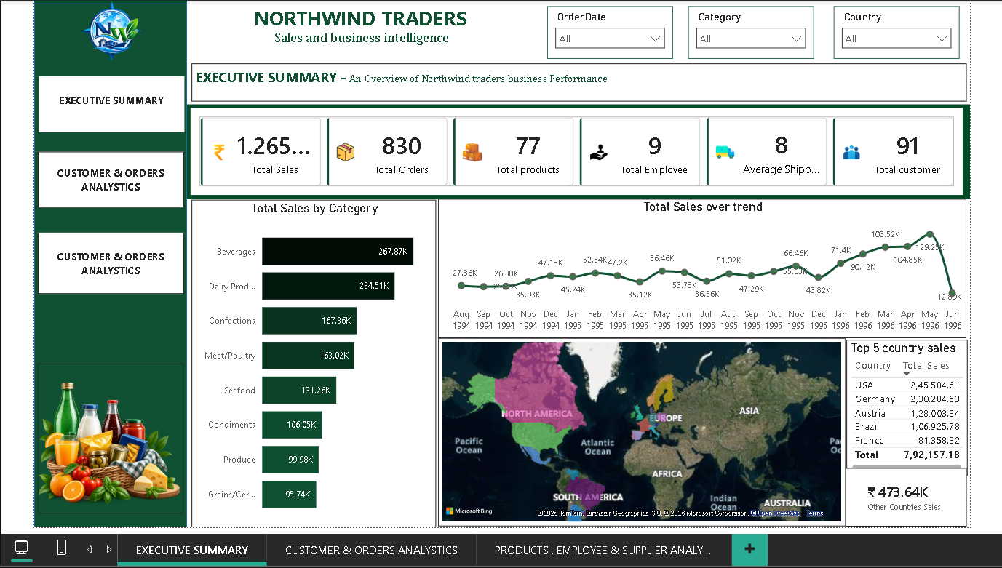
Page 2 – Customer & Orders Analytics
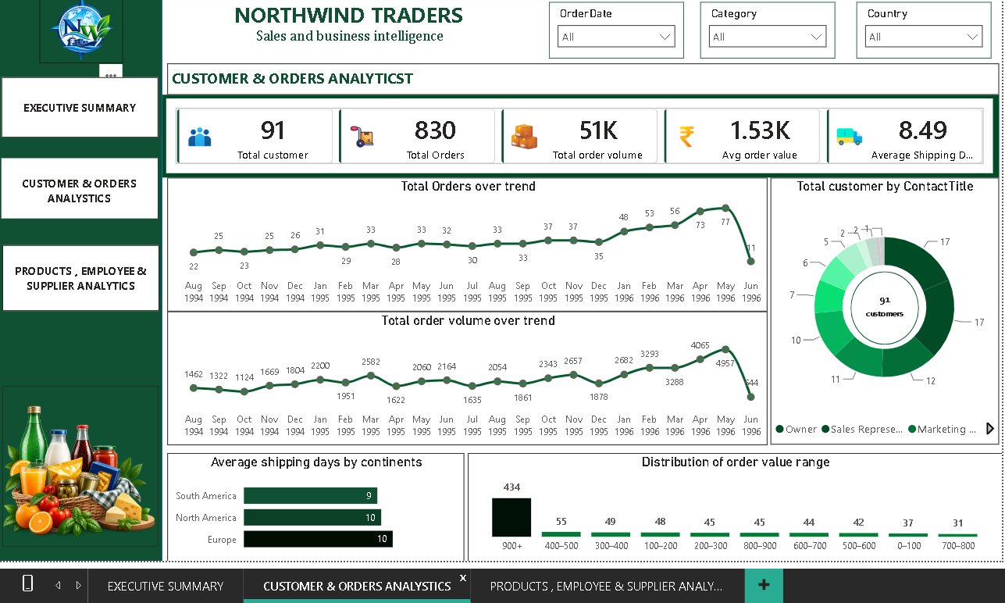
Page 3 – Products, Employee & Supplier Analytics
